Faculty Name: Dr. V. Usha Bala   
Primary Research Area: Machine learning for   
Secondary Research Area: Artificial Intelligence and Machine learning

Project Title: **Sign Language recognition using Machine Learning**

What is Machine learning?

Machine learning is a branch of artificial intelligence and computer science which focuses on the use of data and algorithms to imitate the way that humans learn, gradually improving its accuracy.

Machine learning is the science of getting computers to act without being explicitly programmed. As the number of applications for Automation growing Machine learning and Artificial intelligence also gaining a lot of importance in the world.

What is Sign Language?

There are many people around the globe who are unable to hear/speak. The communication between these people is therefore carried out using a special language called Sign language which is a combination of hand movements, body gestures and face expressions. There are different sign languages across the world for example Americal sign language, British sign language, Indian sign language etc.

What is The Problem?

Thanks to sign language, there is no problem Communicating among the community of people who cannot hear/speak but, there is a problem a problem while communicating with people those who can hear and speak, they expect people to understand what they are saying using their lip movement which is extremely hard. The people who can speak do not know the sign language and vice versa, this is acting as a barrier between both communities.

How do we Solve This Problem?

Due a wide verity of sign language in the world we decided to solve the problem and concentrating on Indian sign language. Although these languages differ if we find a solution for one of these languages, we can do for the others too.

The Idea is to train a Machine learning Model so that it can identify the signs, gestures in the Indian sign language and translate it into English so that we can easily understand and vice versa.

Project development stage 1 **Building a Machine learning model**

In this process we select a machine learning algorithm and using supervised learning we train it with the Signs and gestures in the Indian sign language so that it can recognise and translate these signs in future.

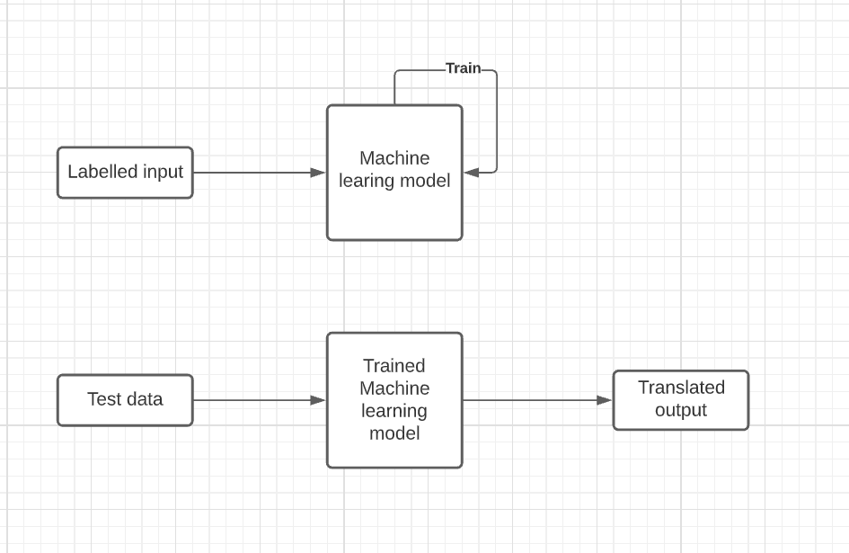

Labelled input: Indian hand signs and gestures with their translations (video)  
 Test data: Indian hand signs and gestures (video)  
 Translated output: Translated meaning of hand signs (Text - English)

Design

We provide input as labelled actions in sign language and train the model using supervised learning. After training the model we test for accuracy we train the model until a reliable accuracy rate. Then the model will be able to translate Indian sign language to English.